



Instructor Guide

Train the Trainers Course
Introduction

Cyber Excepted Service (CES)
Train the Trainers Course Introduction

Instructor Guide

Instructor Guide
Train the Trainers Course Introduction

This page intentionally left blank

Cyber Excepted Service (CES) Train the

Trainers Course
COURSE OUTCOME
The overall course goal is to prepare Human Resources (HR) Professionals on how to guide supervisors and employees covered under the new CES personnel system.
METHODOLOGY
Lecture: Transmit information which supplements or enhances reading; promote understanding via explanations; respond to student misconceptions or difficulties; create or engage interest in a new area; motivate reading or other assignments. Examples of lecture content include: Create interest in the performance management program, promote understanding via explanations; and respond to student misconceptions or difficulties.

Discussions: Practice thinking and communicating in the subject/discipline; evaluate positions, arguments, or designs; defend own position; identify problems, conflicts, and inconsistencies; get feedback from/about students; draw on students’ expertise and prior knowledge.
TARGET AUDIENCE
The primary target audience is HR Professionals covered under CES.

About Facilitating
MATERIALS NEEDED
Be sure you have the following materials, which will be needed to complete the activities:
- Instructor Guide/Slides
- Copies of Lesson 1- Ice Breaker Participant Activity Sheet
- Chart paper/easel (at least 3)
- 3”x3” Post-It notes
- Markers for Chart paper
- Computers
- Microphone

SETUP
Before a training session, be sure that the following setup has been completed:
- Practice with slides on session computer
- Test slides/practice in a room
- Test microphone if used

SPECIAL FACILITATION REQUIREMENTS
Keep the participants actively involved, but watch the time!
BEST PRACTICES
Here are some best practices for facilitating an instructor-led training course.
- Refer to the Instructor’s Guide and rely on the script. Rehearse the script several times so that you can paraphrase it naturally. To the degree, the schedule allows, try to add information that supports or highlights the points being made in the slide (e.g., add examples from your own experience).
- Encourage participation. Accomplish this by asking questions and by having the participants interact as directed.
- Encourage participants to speak in turn.
- Encourage participants to follow along on the slides.
- At the end of the lesson, ask the participants what they remember. Let them summarize the major instructional points if time permits.
- Keep the atmosphere informal so that the participants are comfortable asking questions, participating in activities, and sharing their knowledge or concerns.

COURSE Introduction and Overview
COURSE NAME
Train the Trainers Course Introduction
Duration
2 days
PURPOSE
The purpose of this course is to prepare HR Professionals on how to guide supervisors and employees covered under the new CES personnel system.

COURSE AGENDA
The course contains the following lessons:
- CES DoD Leaders Orientation Course
- CES HR Elements Course:
- Course Introduction
- Background (Introduction to DoD CES Personnel System)
- Occupational Structure
- Employment and Placement
- Compensation Administration
- Course Conclusion

Note: The lessons in this course are designed to be modular, allowing trainers to tailor the delivery of the course. Each lesson can be used as an individual training resource.

Train the Trainers Course Introduction
PURPOSE
The purpose of the Course Introduction is to provide an overview of the Cyber Excepted Service (CES) HR Elements Course in general and to lay out ground rules for course participants.
LEARNING TOPICS
When participants have completed Lesson 1, they will be able to discuss:

- CES Training Approach
- CES Courses:
- CES HR Elements
- CES DoD Leaders Orientation
- CES Workforce Orientation
- Tips For Effective Instruction
- Next Steps

TIME
The following is a suggested time plan for this lesson. The instructor(s) may adapt it as needed. Note this table does not reflect breaks – use your judgment to determine the timing of breaks for participants.

LESSON | SUGGESTED TIME
Train the Trainers Course Introduction | 45 minutes with no break

This page intentionally left blank
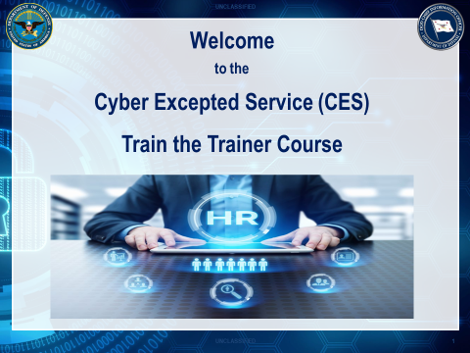

Train the Trainers Course Introduction
DO - Show Slide 1
Display the course title slide as participants arrive for training each morning.
- Welcome participants as they arrive for the class
- Thank them for coming
- Check their names on the class roster and ensure that all of their data on the roster is correct

SAY: “Welcome” to participants as they arrive for the class. Thank them for coming.

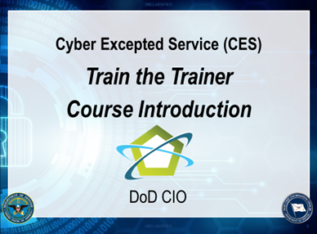

DO - Show Slide 2
This is the beginning of the course. Please leave this slide on the screen, while the Opening and Administrative Remarks (Component POCs) are being delivered.
- At a minimum, have the Component Host POC provide the opening remarks….
If there is not a separate Component Host POC to provide the Administrative/Logistics Remarks, then the instructor should obtain the information for the Administrative Information Slide (slide 4) and provide it to the participants in the next slide.

After the opening and administrative remarks, please thank the Component
Presenter(s)…
- Thank you for providing the opening for this CES Train the Trainer Course OR
- Thank you kindly for your remarks….
(Pause)
Then Transition to the Course Agenda Slide…
Transition: Now, let us walk through our Agenda for this course.

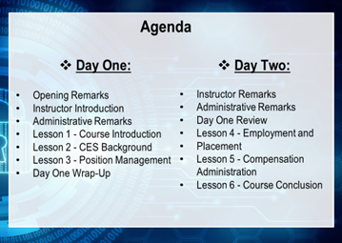

DO - Show Slide 3
Pass out the actual course agenda with times.
SAY: (Quickly review the Agenda with the participants)
(Pause)
Transition: Now, let’s take care of little housekeeping items.

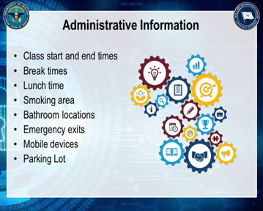

DO - Show Slide 4
Speak to all of the items (or those that were not addressed in the Administrative Remarks)
SAY: Review the housekeeping items with participants. Discuss the points listed on the slide as well as any others that are unique to the facility or class.
Breaks and Lunch: make the point that you will take frequent breaks but will determine when they are most logical, depending on timing in the course content. If possible, it is a good practice to identify a specific time for lunch and adhere to it.
As a final piece of information, declare the clock in the room to be the official “classroom standard time” upon which all start, end, and break periods will be based. If there is no clock, use your watch (or designate someone else to serve as the timekeeper) as the official time source.
Parking Lot: Tell the class that there might be times during the two-day course when you cannot provide an immediate answer to someone’s question. There may also be instances when a question might be answered later in the course. In those cases, you will put the issue in the Parking Lot, so it is not forgotten. Revisit the issues in the Parking Lot as needed and return an answer for each as soon as possible. Point out the location of the Parking Lot in the classroom.
(Pause)
Transition: Now, let’s discuss some ground rules for this course.

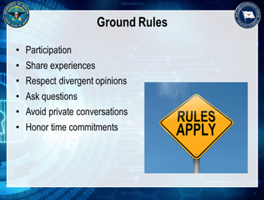

DO - Show Slide 5
Walk the participants through each of the ground rules on the slide.
SAY: Ground rules will help us to get through all of the lessons on schedule and maintain a successful learning environment.
Participation: To get the most out of this class, active participation is required. Active participation helps everyone learn more through the many exercises that require group activity and input.
Share experiences: Sharing individual experiences helps others. Please share successes and some learning experiences that are relevant to the discussions.
Respect divergent opinions: One of the exciting, and sometimes frustrating, aspects of employee relations is that few answers apply to every situation. If you disagree with a statement, do it respectfully.
Ask questions: Questions are strongly encouraged. Remember, there are no dumb questions. One person’s question may well be on the minds of others, too.
Avoid private side conversations: Some topics are going to stimulate your thinking, and it might be tempting to begin discussions with others; however, it is important that everyone hear what is being said in a group discussion.
Honor time commitments: Prompt attendance on everyone’s part is needed to keep things moving efficiently. Please commit to arriving on time and returning on time from lunch and breaks.
(Pause)
ASK: Does anyone have a ground-rule they’d like to add to this list?
(Pause)
Transition: Now, let’s begin some introductions.

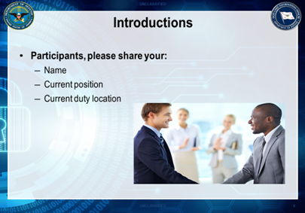

DO - Show Slide 6
SAY: Ask the participants to introduce themselves. Select a person to begin the introductions and continue around the room until everyone has been introduced. Ask them to provide the following information:
• Name, Current position, and Current duty location
(Pause)
Transition: Let’s discuss how CES affects you as an HR Trainer and HR Practitioner.

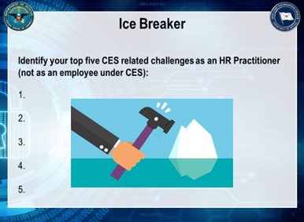

DO - Show Slide 7
Pass out the Train the Trainer- Ice Breaker Participant Activity Sheets
Reconfigure the room for this activity. Mix up the seating arrangements either by tables or have the participants to count-off 1 to 5 to establish new groups.
Allow 20 minutes for this activity:
- 5 minutes for individual work
- 15 minutes for presentation and debrief
SAY: The purpose of this exercise is to give HR Trainers and HR Practitioners an opportunity to identify and share the top challenges they see as related to CES.
Please think about the impact of CES on yourself as an HR professional and not as an employee.
Ice Breaker Instructions (For the Instructor):
Depending on the audience, these challenges could be related to CES as a new separate personnel system, CES as an evolving system, and management engagement needed to support CES.
Have participants use the Train the Trainer- Ice Breaker Participant Activity Sheet to individually answer the question. Have participants rank their list.
Once the individual lists are complete, divide the participants into groups of five. Because participants tend to sit with acquaintances, consider dividing them into groups by having them count off from one to five. This approach creates five diverse groups, allowing participants to hear and learn new perspectives.
Have each group create a list of its top five challenges for the HR Trainer or HR Practitioner under CES, then have groups rank their list of challenges with number one being their top priority. Monitor the group discussions to gain valuable insight into the participants’ hot topics and depth of CES knowledge. Collect the list of challenges so the organization may review them to assess future training needs.

Instead of having groups present their entire list all at once, use a round-robin approach. Ask each group to select a spokesperson to present one challenge at a time, starting with its top priority. Probe where appropriate. Record the challenges on chart paper. If subsequent concerns are duplicates, place a checkmark beside the original.
After every group has reported its top challenge, proceed to the second highest challenge, again asking each group to present one at a time. Three rounds should suffice to surface common trends.
In conclusion, review the list in the context of this course, letting participants know which challenges the course addresses. Remind participants that you will forward challenges beyond the scope of this course to the Office of the DoD CIO.
Refer back to your ‘top 5’ throughout the course.
DO - (Pause)
Transition: Now, let’s take a look at the learning objectives for this course.

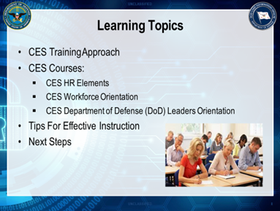

DO - Show Slide 8
SAY: After completing this course, you will be able to discuss a range of topics and effectively deliver training courses-HR Elements, Leaders Orientation, and Workforce Orientation- related to the Cyber Excepted Service including:
The History of CES and its goals, objectives, and strategic direction.
The CES Occupational Structure and how the positions within your Component fit into the structure.
The Alignment process for CES positions.
Employment and Placement considerations are unique to CES and the excepted service.
Basic pay administration, including Local Market Supplement (LMS) and Target Local Market Supplement (TLMS) adjustments to base salary.
The Component, Office of the DoD Chief Information (DoD CIO), and the Under Secretary of Defense for Personnel and Readiness (USD (P&R)) roles relating to the development and administration of CES policies.
Though this might sound like a lot of information, there is no need to be concerned. As I mentioned before, the information is organized into related topics that build on previously covered material. You will leave the course with a good understanding of the topics and how they work together within CES. Additionally, you will have initial CES policies, and a host of training materials to consult should questions arise when you’re back at your office.
Remember, CES is a new and fluid personnel system… So changes and additional guidance will be issued…

It is important to keep in mind that CES is a personnel management system where managers/ supervisors should be the primary drivers of its success. As such, it’s essential that you work together with your managers/supervisors and empower them to take ownership of the system and provide them with the information, support, and tools they need to be successful.
(Pause)
ASK: Do you have any questions, concerns, or comments about the content of this course?
Do not spend a lot of time on this discussion, as later in the lesson, participants are allowed to discuss their concerns about CES in more detail. The focus of this brief discussion is to set expectations about what is covered in this course and what is not.
Address participant concerns by recording them on the flipchart paper. Review the finished list, clearly relating each concern to the scope of the course. If the course content addresses the concern, briefly describe where in the agenda that happens. If the concern falls outside the course’s scope, say so and, if appropriate, provide or commit to provide a helpful resource. Let participants know you will document the comments that are not covered in the course and forward them to the Office of the DoD CIO.
(Pause)
Transition: Let’s turn our attention to the CES Training Courses.

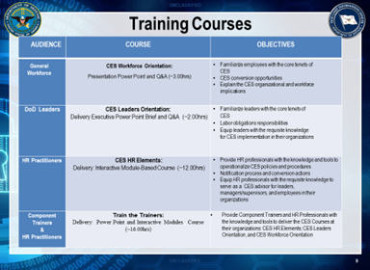

DO - Show Slide 9
SAY: This course will equip you with the necessary knowledge and skills needed to successfully deliver the following CES Training Courses back at your organizations:
The CES HR Elements Course is a one and a half day (12-hours) interactive module-based course that has been designed to provide HR Practitioners with the knowledge and tools to operationalize the new CES policies and procedures. Along with providing an overview of key attributes and implementation process for the new personnel system, this course will examine the following topics: CES occupational structure, compensation administration, employment and placement. DoD Component Instructors will conduct this course to equip HR Practitioners (HR Officers, Specialists, Personnel Action Processors, and Liaisons) with the requisite knowledge to serve as a CES advisor for leaders, managers/supervisors, and employees in their organizations.
The CES DoD Leaders Orientation Course is a 2-hour executive presentation (including a question and answer segment) that has been designed to familiarize DoD Leaders with core tenets of the new DoD CES personnel system. This course provides an overview of the history, policies, key attributes, and implementation process for the new personnel system. DoD Component Instructors will conduct this course to equip DoD Component Leaders, Supervisors, and Managers with the requisite knowledge to champion and lead CES implementation at their organizations. Upon the completion of this course, the participants will have the knowledge needed to assist employees with understanding the new personnel system.
The CES DoD Workforce Orientation Course is a 3-hour presentation (including a question and answer segment) that has been designed to familiarize the workforce with the core tenets of the new DoD CES personnel system. This course provides an overview of the history, policies, key attributes, benefits, and implementation process for the new personnel system. DoD Component Instructors will conduct this course to equip the workforce with a solid understanding of the key elements of the new personnel system. Upon the completion of this course, the participants will know of the CES organizational and workforce implications.
Transition: Now, let’s examine the tools that are readily available to assist you with training delivery.

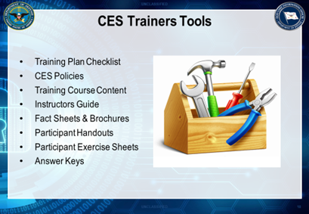

DO - Show Slide 10
SAY: Together, the Office of the DoD CIO and the Defense Civilian Personnel Advisory Services Office have developed all the necessary training course materials and tools for DoD Component Instructors to deliver CES Training Courses at their local organizations.
Today we will walk through a good portion of these tools with you. These tools include:
- Training Plan Checklist
- CES Policies
- Training Course Content
- Instructors Guide
- Fact Sheets & Brochures
- Participant Handouts
- Participant Exercise Sheets
- Answer Keys

All of these materials are housed and regularly updated on the Defense Civilian Personnel Advisory Service Cyber Exchange Website
Transition: Now that we have considered the tools, let’s explore some tips for effective instruction.

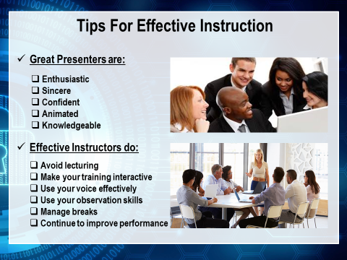

DO - Show Slide 11
SAY: Your role as an HR Trainer or HR Practitioner is critical to the success of your Organization’s transition to CES. We are standing by to support you!
Now let’s take a look at some of the key characteristics of great presenters.
When asked about the personal characteristics that best describe the “perfect” presenter, course participants say they want a presenter who is:
- Enthusiastic: Demonstrate to the participants that you are glad to be there.
- Sincere: Your words and actions must be believable and consistent with your professionalism outside the classroom.
- Confident: Being well prepared will help increase your confidence.
- Animated: Course participants prefer instructors who aren’t glued to the podium and have a positive, upbeat personality. Be yourself while maintaining your professionalism. Most of all enjoy yourself!
ASK: Ask the Participants: What are some other characteristics of great presenters?

(Conduct a brief round-robin discussion on additional characteristics)
SAY: Now let’s consider some general tips for effective instruction:
Tip #1: Avoid Lecturing
- Do not read or lecture to the group.
- Think back to the last class you attended. If the instructor lectured continually, chances are you tuned out and did not learn much. The content in the Instructor Guide is a guide, not your script. Flexibility is the key to success. Please feel free to change the wording of the content to fit your style or meet the needs of the group. And do NOT read the slides to the participants. Rather, summarize the points being made.
- Make yourself part of the group.
- Do not separate yourself physically from the participants by standing behind a podium, an overhead projector, or a table. By physically separating yourself, you look as if you are trying to hide and worse as if you are not interested or open to input from the participants.
- Feel free to walk around the room while you are speaking. Be sure to circulate among the table groups during exercises to see how the participants are doing.
Tip #2: Make Your Training Interactive
- Use techniques to engage and draw out the participants.
- Adults are more interested in being active versus passive participants. If they are forced to be passive, they are likely to lose interest.
- The following are some suggestions for engaging the participants:
- Have Everyone “Check-In” Early: Have all the participants introduce themselves or say something within the first hour of the training. It is important to get everyone comfortable speaking within the group setting.
- Use Open-Ended Questions:
  - Do not just ask participants yes or no OR true or false questions.
  - Foster their critical thinking.
  - Allow them to demonstrate that learning is occurring.
Don’t Be Afraid of Silence: When you are trying to encourage participation, it is critical that you are comfortable with a little silence. If you ask a question and nobody responds:

- Wait. Count to five. Participants are far more uncomfortable with the silence than you are.
Also, know that the time seems to pass slower when you are standing in front of the room. Do NOT answer your question!
- Next, restate the question and make eye contact with someone that you know is likely to answer.
- Again, wait for a response.
- If there is still no response, then suggest a partial answer and ask the participants if they agree or if they have anything to add.
- Ask Someone to Share a True Story: Based on your knowledge of the group, ask a specific individual to relate a true story that you know will illustrate the instructional point being made.
- Acknowledge Contributions: When someone comments acknowledge his or her contribution by:
- Paraphrasing the statement in your own words. Include the individual’s name in your response. For example, “So, Pat, your point is . . .”
- Write a summary of the participant’s statement on the easel pad page/s.
Tip #3: Use Your Voice Effectively
- You can make your presentations more interesting by using your voice effectively.
- Some tips on using your voice include the following:
- Make sure you speak loudly enough so that all of the participants can hear you. A low or quiet voice is hard to hear and can put a group to sleep.
- Don’t speak in a monotone voice. The easiest way to lose the participants’ attention is by speaking in the same voice for a long period.
- Alternate the pace of your voice. If you speak at different speech rates for short periods, you can add some energy and dynamic flow to the presentation.
- Slow down for important points. You can verbally emphasize key points by slowing down.
- Use the pause. Silence is an excellent exclamation point. By slightly extending a pause, you can add emphasis and importance to the key points in your presentation-all presenter’s pause. The best presenters plan their pauses for maximum impact!
Tip #4: Use Your Observation Skills
Observe how the participants respond to your presentation.
- Watch for both verbal and nonverbal responses. Use your observations to help keep the session running smoothly.
- Share your observations with the participants when appropriate.
  - For example, if people are bored or falling asleep, liven up the session by involving people more – ask questions, pose scenarios, and get people engaged.
Tip #5: Manage Breaks
- Don’t go too long without a break.
- As a general rule, participants need a break every hour for about 10 minutes.
- Although most participants will let you know when they need a break, you should watch for nonverbal signs, including glazed eyes, shifting in seats, falling out of seats, or snoring. Try to find natural breaking points in the course as needed. Of course, you will need to adjust the timing of breaks according to what is going on in the course.
  - Note: It is important to enforce break time limits. Resume training promptly at the end of a break - do not linger!
Tip #6: Continue To Learn and Improve
- Use each class you instruct as a resource for the next one.
- Consider the reaction of previous participants when you present the course to a new group. Pay attention to responses and review evaluation feedback to get ideas about how to improve. Do not be afraid to revise your approach, always keeping in mind that all the information must be covered.
- Assess and improve your performance as an instructor.
- After the course, reflect on what you did well and in what areas you need to improve. If you work with a co-instructor, hold a “debriefing” session at the end of each day to discuss strengths, areas of improvement, and modifications for the next day or future courses.
(Pause)
Transition: Let’s turn our attention to where we can get current CES information and training materials.

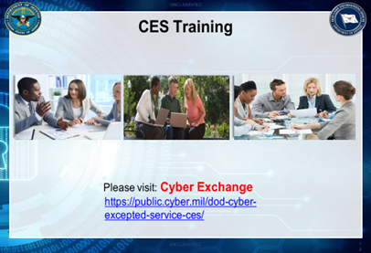

DO - Show Slide 12
SAY: Supporting the new Cyber Excepted Service personnel system for all or some employees in your Component is an important responsibility that you have as an HR Trainer or HR Practitioner.
That responsibility requires a thorough, practical understanding of the system. The goal of this course is to provide you with this understanding.
This course provides a detailed overview of HR practices and policies.
Visit the DCPAS Cyber Exchange Web Site to view a list of additional CES courses that are currently available.
Next, we’ll explore the Workforce Orientation Course, which will bring it all together by highlighting all of the key areas of the CES.

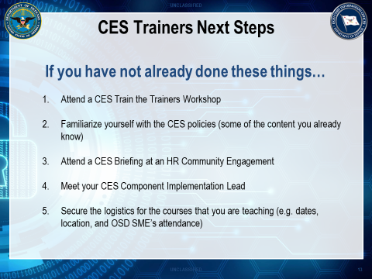

DO - Show Slide 13
Review the actions on the slide. Open the floor for any questions.

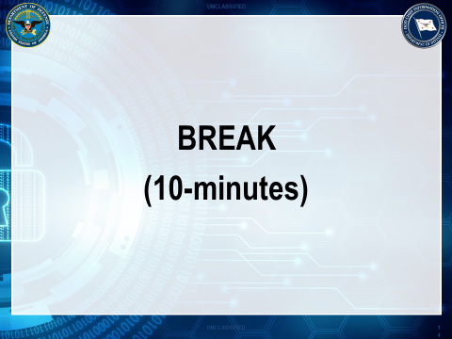

DO - Show Slide 14
SAY: Let’s take a brief pause (10-minute break), before we transition into the next lesson.
Then we will immediately begin the Leaders Orientation Course.

This page intentionally left blank

