

 Instructor Guide
Lesson 2 Background


Cyber Excepted Service (CES)
Workforce Orientation
Instructor Guide



- CES Rev.3 Instructor Guide - Lesson Workforce

This page intentionally left blank
- CES Rev.3

Cyber Excepted Service (CES) HR Elements Course, Lesson Workforce Orientation
COURSE OUTCOME
The outcome of Lesson Workforce Orientation is to prepare Workforce Professionals to transition to the Cyber Excepted Service new personnel system.
METHODOLOGY
Lecture: Transmit information which supplements or enhances reading; promote understanding via explanations; respond to student misconceptions or difficulties; create or engage interest in a new area; motivate reading or other assignments. Examples of lecture content includes: Create interest in the performance management program, promote understanding via explanations; and respond to student misconceptions or difficulties.

Discussions: Practice thinking and communicating in the subject/discipline; evaluate positions, arguments, or designs; defend own position; identify problems, conflicts and inconsistencies; get feedback from/about students; draw on students’ expertise and prior knowledge.
TARGET AUDIENCE
The primary target audience is Workforce Professionals who are covered under a CES designated component or organization.

About Facilitating
MATERIALS NEEDED
Be sure you have the following materials, which will be needed to complete the activities:
- Instructor Guide/Slides
- Copies of Lesson 1- Ice Breaker Participant Activity Sheet
- Chart paper/easel (at least 3)
- 3”x3” Post-It notes
- Markers for Chart paper
- Microphone
- Computer

SETUP
Prior to a training session, be sure that the following setup has been completed:
- Practice with slides on session computer
- Test slides/practice in room
- Test microphone if used

SPECIAL FACILITATION REQUIREMENTS
Keep the participants actively involved, but watch the time!
BEST PRACTICES
Here are some best practices for facilitating an instructor-led training course.
- Refer to the Instructor’s Guide and rely on the script. Rehearse the script several times so that you can paraphrase it in a natural way. To the degree the schedule allows, try to add information that supports or highlights the points being made in the slide (e.g., add examples from your own experience).
- Encourage participation. Accomplish this by asking questions and by having the participants interact as directed.
- Encourage participants to speak in turn.
- Encourage participants to follow along on the slides.
- At the end of a lesson, ask the participants what they remember. Let them summarize the major instructional points, if time permits.
- Keep the atmosphere informal so that the participants are comfortable asking questions, participating in activities, and sharing their knowledge or concerns.

COURSE Workforce
COURSE NAME
Lesson CES Workforce
Duration:
60 minutes

PURPOSE
The purpose of Lesson Workforce Orientation is to prepare Workforce Professionals to transition to the Cyber Excepted Service new personnel system.

LESSON: Workforce
PURPOSE
The purpose of Lesson Workforce Orientation is to prepare Workforce Professionals to transition to the Cyber Excepted Service new personnel system.
TIME
The following is a suggested time plan for this lesson. The instructor(s) may adapt it as needed. Note this table does not reflect breaks – use your judgement to determine the timing of breaks for participants.

LESSON | SUGGESTED TIME
Lesson 2: CES Workforce | 50 minutes with one 10 minute break

Instructor Notes
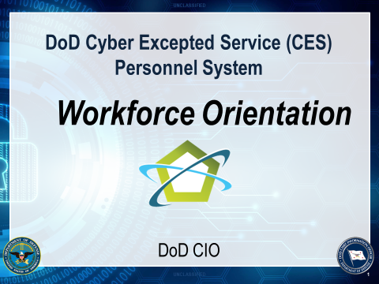
LESSON: Workforce Orientation
DO - Display the course title slide as participants arrive for training each morning.
- Welcome participants as they arrive for the class
- Thank them for coming
SAY: Welcome participants as they arrive for the class. Thank them for coming.

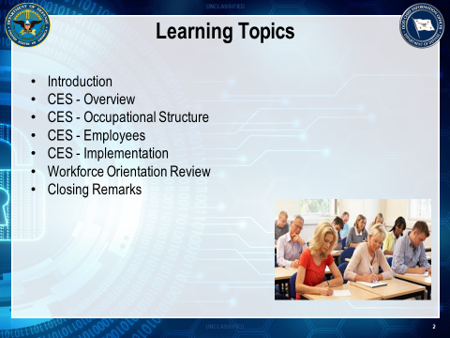

DO - Show Slide 2

SAY: After completing this lesson, you will be knowledgeable about:

- CES - Overview (Background)
- CES - Occupational Structure
- CES - Employees

- CES - Implementation

Transition: Next is Cyber Excepted Service - Overview (Background) section.

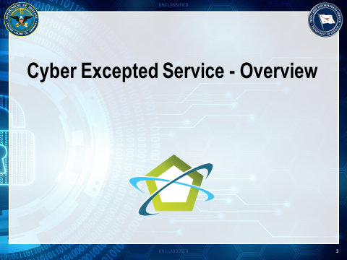

DO - Show Slide 3

Transition: Let’s understand Cyber Excepted Service.

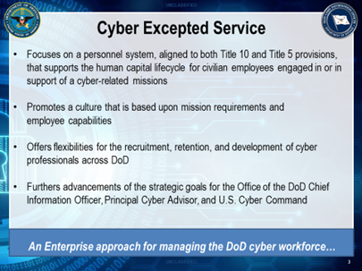

DO - Show Slide 4

SAY: With the official issuance of these personnel policies, the Department now has an Enterprise approach for managing the DoD cyber workforce.

The Cyber Excepted Service is a mission-focused personnel system that:

- Is aligned to both Title 10 and Title 5 provisions

- Supports the human capital lifecycle for civilian employees engaged in or in support of a cyber-related mission

- Offers flexibilities for the recruitment, retention, and development of cyber professionals across DoD

- Further advances the strategic goals of the Office of the DoD Chief Information Officer, Principal Cyber Advisor, and U.S. Cyber Command

Transition: Let’s further examine CES history and evolution.

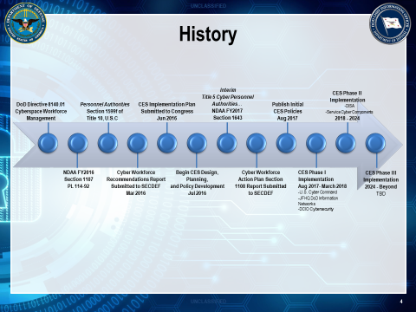

DO - Show Slide 5

SAY: Prior to Fiscal Year 2016, there was no statutory authority to establish the DoD Civilian Cyber Community under a common personnel management system.

The National Defense Authorization Act (NDAA) for FY2016 granted the Secretary of Defense (Sec Def) the authority to establish a new personnel system for cyber positions in the Department - Cyber Excepted Service (CES) Personnel System.

CES was designed as a new mission-focused management system that would bring about essential changes, preserve the core and enduring values of the United States civil service, and support the DoD Cyber Community’s critical national security mission.

As previously stated CES derives its authority from Title 10 USC, Section 1601 and utilizes a common excepted service civilian personnel authority for its civilian cyber positions within DoD.
Beginning soon after enactment, the Office of the DoD Chief Information Officer (DoD CIO), in partnership with the Principal Cyber Advisor (PCA), the Office of the Under Secretary of Defense for Personnel & Readiness (USD (P&R)), and the Office of the Under Secretary of Defense for Intelligence (USD (I)), began designing and planning the key elements of the new personnel system.

- In March 2016, the Cyber Workforce Recommendations Report was submitted to Secretary of Defense.

- In June 2016, the Cyber Excepted Service Implementation Plan was submitted to Congress.

- In December 2016, the Office of the Secretary of Defense Tri-Chairs (DoD CIO, USD (P&R), and PCA) approved the scope and phasing plan for CES implementation.

- In August 2017, the initial CES policies were signed and issued by the USD (P&R).

Transition: Let’s look at the Scope and Applicability to CES.

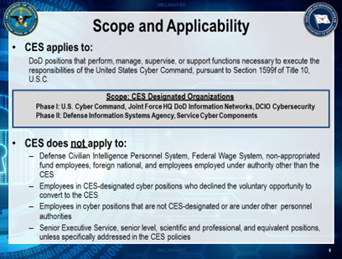

DO - Show Slide 6

SAY: In accordance with Section 1599f of Title 10, USC the following whole organizations and/or their respective sub-elements have been designated for CES implementation:

- U.S. Cyber Command, Joint Force HQ DoD Information Networks, DCIO Cybersecurity, DISA HQ (Ft. Meade), Service Cyber Components

- CES coverage includes both cyber and cyber support professionals

- As stated in all 4 of the policies, the CES does not apply to:

- Defense Civilian Intelligence Personnel System, Federal Wage System, Non-appropriated Fund, Foreign Nationals, Senior Executive Service, Senior Level, Scientific and Professional employees

- Employees employed under personnel authorities other than the CES

- Employees who declined the voluntary opportunity to convert to the CES

Transition: The specifics of the CES are contained in 4 Volumes (3001, 3005, 3006, and 3007). Let’s turn our attention to them.

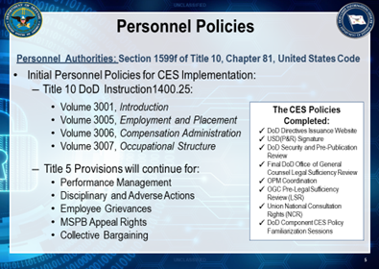

DO- Show Slide 7

SAY: The Office of the DoD Chief Information Officer (DoD CIO), in partnership with the Principal Cyber Advisor (PCA), the Office of the Under Secretary of Defense for Personnel & Readiness (USD(P&R)), and the Office of the Under Secretary of Defense for Intelligence (USD(I)), developed the first four policies for implementing this new personnel system.

These policies were just signed and issued by the Under Secretary for Personnel and Readiness on 15 August 2017.

These initial volumes for CES implementation are:

- DoDI 1400.25, Volume 3001, CES Introduction establishes the policies, responsibilities, procedures, definitions, and delegations for the development, management, and evaluation of the personnel system. This policy prescribes the overall scope of the new personnel system, along with the opportunity for competitive service employees to voluntarily convert to the CES. If an employee declines to voluntarily convert to CES, the CES-designated position will be converted to CES when vacated by that employee.

- DoDI 1400.25, Volume 3005, CES Employment and Placement establishes the policies, responsibilities, procedures, and delegations for the design and administration of employment and placement programs. This policy prescribes the excepted service recruitment and placement procedures, flexibilities for candidate sourcing, qualification requirements, probationary periods, veterans’ preference, and reinforces the application of merit system principles. The Office of Personnel Management has established a Legal Authority Code for processing CES personnel actions.

- DoDI 1400.25, Volume 3006, CES Compensation Administration establishes the policies, responsibilities, procedures, and delegations for the design and administration of compensation programs. This policy prescribes the CES compensation structure (Base Pay + Local Market Supplement), flexibilities and incentives, pay setting, and promotion procedures. The GG pay plan and graded structure has been established for CES implementation.

- DoDI 1400.25, Volume 3007, CES Occupational Structure establishes the policies, responsibilities, procedures, and delegations for the design and administration of the CES occupational structure. This policy prescribes the elements of the CES occupational structure and the respective grading standards for classifying CES non-supervisory and supervisory positions. CES will be implemented under a rank-in-position construct.

Together these initial CES Volumes have established a common framework for the DoD CES Components.

Since every HR Practitioner must know how to address client questions on a wide variety of topics. The CES Volumes are where you should turn for answers. Additionally, the Volumes serve as the basis for any local guidance that Components develop.

- Please remember that there is not a requirement or a need for each affected Component to re-write the policies that were just issued. Rather the expectation is that each Component, would issue guidance for the areas that require specific Component-level procedures and/or approvals for execution.

(Pause)

ASK: Are there any questions about the policies?

Transition: Let’s begin with an examination of just “why” the Department needed another personnel system.

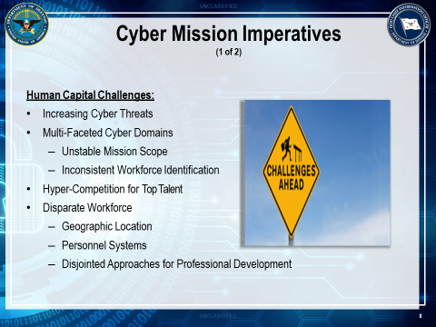

DO - Show Slide 8

SAY: The unprecedented nature of cyber plagues the Department with some very unique challenges:

- A daily increasing number of cyber threats; multi-faceted cyber domains; and unstable mission scope.

- Coupled by the inconsistent management and identification of our disparate cyber professionals. We need their talent but have yet to truly define what the mission critical skills are, where they are located, and the strategy for developing and retaining them.

- DoD uniformed service members, civilians, and contractors are all competing for a very small, but specific pool of talent.

- The Department’s cyber mission has a severe human capital crisis.

Transition: In response to these human capital challenges, there were some very significant demand signals for change across the Enterprise.

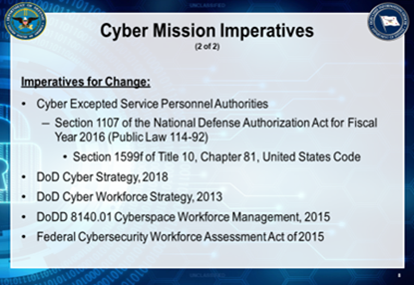

DO - Show Slide 9

SAY: The strategic imperatives for change - to intentionally resolve the Department’s cyber recruitment, development, a retention challenges- were deemed as a strategic priority in:

- DoD Cyber Strategy, 2018

- DoD Cyber Workforce Strategy, 2013

- DoDD 8140.01 Cyberspace Workforce Management, 2015

- Federal Cybersecurity Workforce Assessment Act of 2015

- Then, Section 1107 of the National Defense Authorization Act for Fiscal Year 2016 provided the Department with the personnel authorities to establish the Cyber Excepted Service by virtue of the Section 1599f of Title 10, Chapter 81, United States Code

Transition: Let’s look at the CES key attributes.

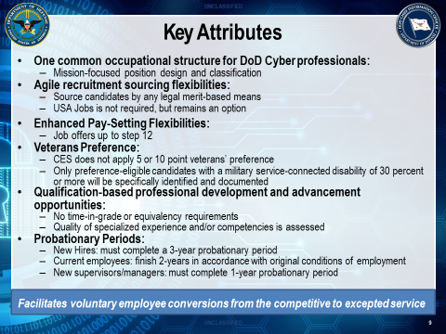

DO- Show Slide 10

SAY: Throughout this course, we will explore the CES key attributes and flexibilities in greater detail.

These attributes include:

- One common occupational structure for DoD Cyber professionals

- Qualification-based (instead of time-in-grade) professionals develop and advancement opportunities

- Agile recruitment sourcing flexibilities

- Market-based compensation

- Voluntary conversions from the competitive service to the excepted service

- Maintains current Title 5 protections, appeal rights, and collective bargaining agreements

Transition: Let’s dig a little further into the underlying design concepts of the CES.

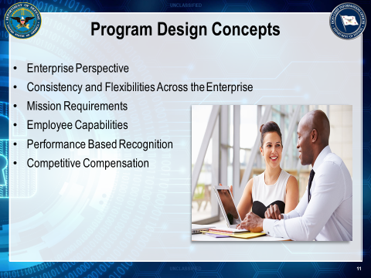

DO - Show Slide 11

SAY: The CES Design included the following key concepts:

- Enterprise Perspective: CES reflects the principle that there is one Defense Cyber Enterprise. All the individual Components must function as a part of the Enterprise.

- Consistency across the Enterprise: consistency across the Enterprise allows for the most effective and efficient use of available resources, such as people and money, and it supports a consistent performance management perspective with the Cyber Community.

- Mission Requirements and Employee Capabilities: the CES is committed to developing agile workforce to fulfill the Department’s unprecedented cyber mission requirements. Enhanced employee capabilities drive organizational performance and performance drives decisions about performance based recognition for those organizations operating under CES.

- Performance-Based Recognition: under the CES graded structure, contributions to mission are recognized through within-grade increases and non-monetary and monetary awards in accordance with the DoD Performance Management and Appraisal Program.

- Competitive Compensation: market pay is the current salary range companies or organizations within a given market are willing to pay for a particular skill set and level of experience. To help Components compete with the market and attract and retain top talent, CES provides a competitive compensation system that will be further enhanced in the near future.

Transition: Let’s look at the CES Recruitment and Staffing.

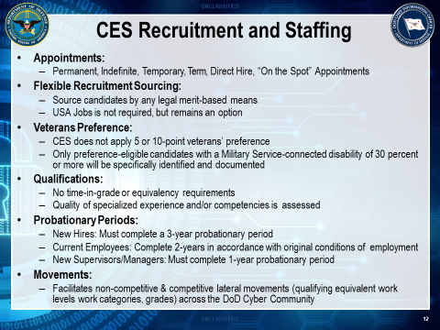

DO - Show Slide 12

SAY: Here are some critical elements to keep in mind regarding CES Recruitment and Staffing (cite real life examples to workforce participants):

- Appointments:
  - Permanent, Indefinite, Temporary, Term, Direct Hire, “On the Spot” Appointments
- Flexible Recruitment Sourcing:
  - Source candidates by any legal merit-based means
  - USA Jobs is not required, but remains an option
- Veterans Preference:
  - CES does not apply 5 or 10-point veterans’ preference
  - Only preference-eligible candidates with a Military Service-connected disability of 30 percent or more will be specifically identified and documented
- Qualifications:
  - No time-in-grade or equivalency requirements
  - Quality of specialized experience and/or competencies is assessed
- Probationary Periods:
  - New Hires: Must complete a 3-year probationary period
  - Current Employees: Complete 2-years in accordance with original conditions of employment
  - New Supervisors/Managers: Must complete 1-year probationary period
- Movements:
  - Facilitates non-competitive & competitive lateral movements (qualifying equivalent work levels work categories, grades) across the DoD Cyber Community

Transition: Next is Cyber Excepted Service – Occupational Structure section.

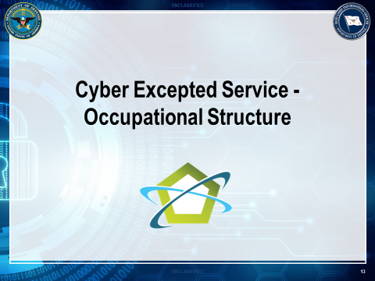

DO - Show Slide 13

Transition: Let’s understand CES Occupational Structure.

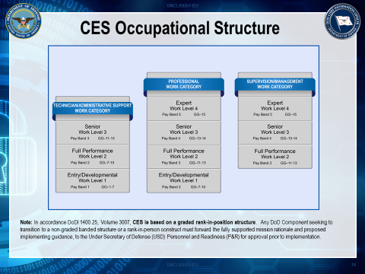

DO - Show Slide 14

SAY: The CES Occupational Structure allows for work to be assigned and positions to be organized in a way that best accomplishes the Department’s cyber mission, while upholding the merit principle of equal pay for work of equal value.

The Occupational Structure follows common core policies and processes for structuring, categorizing, and aligning civilian work that supports both position-based and person-based structures.

Mission categories, work categories, work levels, and grades comprise the Occupational Structure for all Defense Cyber Components.

Transition: Let’s review Position Alignment.

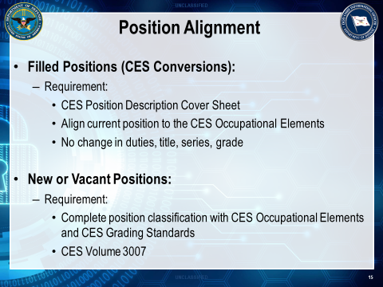

DO - Show Slide 15

SAY: CES is exempt from Title 5 position classification procedures. Hence, the process for CES position classification, although similar in nature, differs from that of the competitive service.

The CES Alignment Process, places positions in the CES Occupational Structure.

Transition: Let’s review Compensation.

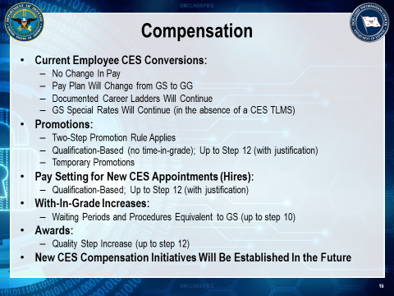

DO - Show Slide 16

SAY: Here are some critical objectives to keep in mind regarding Compensation (cite real life examples to workforce participants):
- Current Employee CES Conversions:
- No Change In Pay
- Pay Plan Will Change from GS to GG
- Documented Career Ladders Will Continue
- GS Special Rates Will Continue (in the absence of a CES TLMS)
- Promotions:
- Two-Step Promotion Rule Applies
- Qualification-Based (no time-in-grade); Up to Step 12 (with justification)
- Temporary Promotions

- Pay Setting for New CES Appointments (Hires):
- Qualification-Based; Up to Step 12 (with justification)

- With-In-Grade Increases:
- Waiting Periods and Procedures Equivalent to GS (up to step 10)

- Awards:
- Quality Step Increase (up to step 12)

- New CES Compensation Initiatives Will Be Established In the Future

Transition: Let’s review Compensation Key Terms & Occupational Categories (Pay) Adjustments.

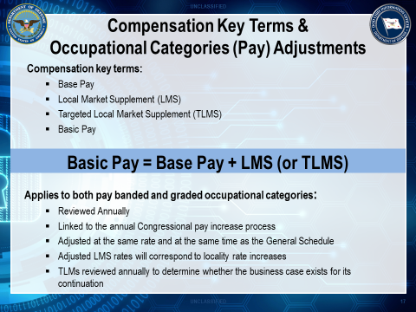

DO - Show Slide 17

SAY: Base Pay is an employee’s salary rate before any local market supplement (LMS), targeted local market supplement (TLMS), or other adjustment is added.
The base pay structure provides a common pay structure for worldwide use. LMS or TLMS are added to base pay to reflect regional, occupational, organizational, or other labor market requirements.
The Local Market Supplement (LMS) is an addition to the base pay of employees assigned to a geographic region that reflects the labor market in that region. These rates generally correspond to the locality rates established by the Office of Personnel Management (OPM) for the General Schedule (GS).
Targeted Local Market Supplement (TLMS) is another type of addition to the base pay of employees established in response to labor market conditions not fully addressed by the Grade rate ranges and LMSs. To ensure that qualified Cyber Community employees are hired and retained, TLMSs may be established for employees in specific:
- Local market areas (or worksites) that are a subset of, or that cross, established locality area boundaries
- Occupations or specializations (e.g. polygraphers)
- TLMSs may cover one or more work categories and/or work levels, inclusive of employees in grades included in the work level(s). An employee receiving a TLMS cannot also receive an LMS.
LMS or TLMS serve the same function under CES as locality pay and special salary rate supplements serve within the General Schedule.
An employee cannot receive both LMS and TLMS
Basic Pay is an employee’s regular rate of pay for premium pay and retirement calculations. It consists of base pay and any LMS or TLMS supplement.
Other allowances and entitlements such as Cost-of-Living Allowance (COLA), post differentials, and danger pay are not part of basic pay.
Basic pay = Base pay + LMS (or TLMS). Another way to look at it is that base pay plus an LMS or TLMS equals adjusted or basic pay.
(Pause)
SAY: In terms of Occupational Categories (Pay) Adjustments, the following apply to both Pay Banded and graded compensation structures:
ADMIN NOTE: During the initial CES implementation only the graded rank-in-position category will be used for all Defense Cyber components. Therefore, the primary focus of this lesson is on the graded category and not the pay banded category.
- Reviewed annually
- Linked to the annual congressional pay increase process
- Adjusted at the same rate and at the same time as the General Schedule
- Adjusted LMS rates are adjusted to correspond to locality rate increases
- Reviewed each TLMS annually to determine whether the business case exists for its continuation; it may be decreased, increased, or eliminated
Let’s look at Occupational Categories (Pay) Adjustments in more detail.
An employee’s performance affects his or her eligibility for pay increases under the graded compensation structure. In the graded structure, employees advance through the grade by receiving within-grade increases.
When GS locality rates are adjusted based on an Executive Order (EO) or by an act of Congress, corresponding CES LMS rates based on GS locality rates will be adjusted automatically by the same percentage as the GS locality rates. Adjustments to CES LMS rates based on GS locality rates will be effective the first full pay period beginning in January of each year. Any adjustments to LMS rates that have been created must be approved by the DoD CIO in conjunction with the USD Personnel and Readiness (P&R).

Employees in the graded structure receive the congressional adjustment to base pay.
CES policy currently adjusts the graded structure to parallel any increases granted to the GS.
Employees who are on pay retention receive 50% percent of any increase to the maximum of the rate range, or to the maximum rate for their GG in the graded structure, including the extended pay range. If the rate range adjustment causes the grade maximum to exceed an employee’s retained rate, pay retention terminates and the employee may receive the full pay increase, or that portion of the increase to align the employee’s salary to the maximum for his or her pay band or grade.
When a LMS is increased or decreased as a result of the annual market analysis or for other reasons (e.g., EO), the adjustment applies to all employees receiving the supplement regardless of current performance evaluation rating of record. Pay retention pursuant to this Volume does not apply in the case of a reduction in an employee’s pay that results from a reduction in an LMS. This reduction in an employee’s pay does not constitute an adverse action. The Department of Defense (DoD) Chief Information Office (CIO) in conjunction with the Under Secretary of Defense (USD) Personnel & Readiness (P&R), sets, modifies, or eliminates CES TLMS based on mission staffing challenges, labor market conditions, and comparability with similarly situated employees of other federal agencies and the DoD and any other factors.
Such TLMS rates will be effective the first full pay period beginning in January of each year.
Later in this lesson we will discuss LMS/TLMS in more detail.

Transition: Let’s move on to Cyber Excepted Service – Employees section.

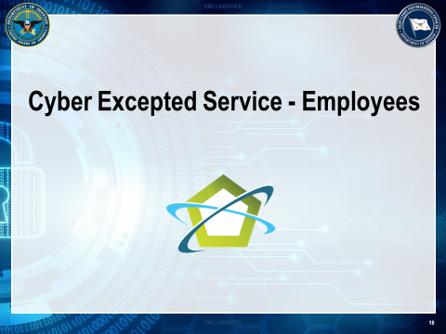

DO - Show Slide 18

Transition: But for now, we’ll take a few minutes to familiarize you with your responsibilities as an HR Practitioner as well as the responsibilities of Employees, Managers/Supervisors, and Senior Leaders.

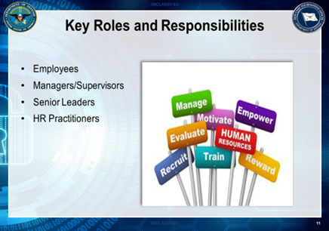

DO - Show Slide 19

SAY: Here are the key roles and responsibilities for Employees, Manager/Supervisors, Senior Leaders, and HR Practitioners.

Employees:

- Educate Yourself on the CES:
- Familiarize yourself with the CES Policies, Training, Fact Sheets, and Website

- Stay Informed About CES:
- Attend CES Events, Briefs, Town Halls, and Road Shows

- Communicate With Other About CES:
- Talk to your Local CES Component Leads and Supervisors

- Ask Questions About CES:
- Ask the DoD CIO CES Team Questions

Managers/Supervisors:

- Be the primary champion and driver behind CES

      - Help establish and communicate the strategic mission goals for the organization

      - Ensure labor obligations are met

      - Be familiar with the goals and priorities of your organization and ensure your employees’ performance objectives align with them

Senior Leaders:

- Set the tone and high-level expectations

- Help establish and communicate the strategic mission goals for your organization

- Prepare your staff for the changes brought by CES (includes pre-decisional involvement with labor organizations)

- Support the effort by providing adequate resources for CES implementation

- Encourage open communication about CES

- Lead the change by modeling your commitment as a leader and advocate of CES

HR Practitioners:

- Empower leaders, managers, supervisors with the information they need to be the primary drivers behind the Cyber Excepted Service. Ensure that labor obligations are met

- Ensure employees understand the facts about CES (what it is and what it is not) and their role within it

- Ensure leaders understand the flexibilities and opportunities built into policy to help them best meet the needs of their workforce

- Familiarize yourself with the training courses and materials available on the DCPAS Cyber One Stop Website and point individuals to these resources when they need additional information and/or training.

- Look for ongoing opportunities to communicate the benefits and capabilities of the new CES to employees, managers, supervisors, and leaders

- Be prepared to explain and answer questions about the CES to your employees

Transition: Let’s take a look at preparing to enter CES.

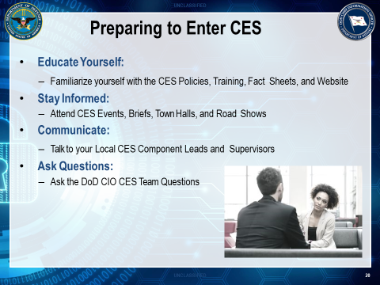

DO - Show Slide 20

SAY: Department of Defense – CES Component and Organizations must do the proactive messaging to ensure workforce employees are prepared for the new personnel system.

- Educate Yourself:
  - Familiarize yourself with the CES Policies, Training, Fact Sheets, and Website
- Stay Informed:
  - Attend CES Events, Briefs, Town Halls, and Road Shows
- Communicate:
  - Talk to your Local CES Component Leads and Supervisors
- Ask Questions:
  - Ask the DoD CIO CES Team Questions

Transition: Let’s take a look at preparing to enter CES

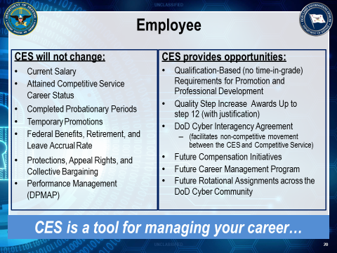

DO - Show Slide 21

SAY: CES is a tool that will help employees manage their career as cyber professionals.

Let’s review just why employees should consider CES:

      - Converting from a competitive services to the Cyber Excepted Service, will not negatively impact employees (walk thru the entire list):

- You will not lose any money

- Attained competitive service status will not change; You can be reinstated back to the competitive service

- If you have completed your probationary period you will not have to complete a new one; If you are in the process of completing one, then you will have to complete it in accordance with your original conditions of employment

- Your Federal benefits, retirement, TSP, and leave accrual will continue as is CES is aligned to the current DoD Title 5 policies that ensures that your protections, appeal rights, and collective bargaining agreements will continue

Your DPMAP performance cycle will not change

- Instead, CES offers a new perspective for advancing the workforce:

- A focus on the quality of your work experiences, rather than on amount of time that you spent in them; there is no time in grade requirement for promotions and professional development opportunities

- Up to step 12 promotion and award opportunities with justification

- A host of new initiatives that will be developed in the near future, including new compensation initiatives after the required market analysis and business case is completed; a cyber-career management program; and rotational assignments across the Cyber Community

Transition: Along with considering what CES provides our employees, let’s review the opportunities that it brings to our Supervisors/Managers.

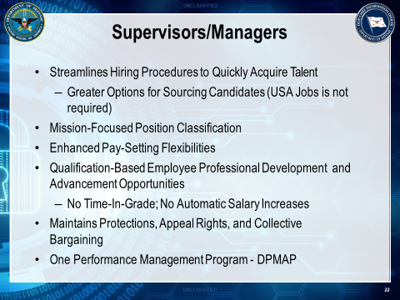

DO - Show Slide 22

SAY: CES will enable the Department to quickly hire and retain the right people at the right time.
Specifically, CES will alleviate some of the administrative burdens and offer some flexibilities to aid our supervisors and managers:

      - Under the CES, hiring managers can source candidates from any legal merit-based means and USA Jobs is no longer a requirement for hiring, but now one of the many options

      - A common occupational structure, where positions are aligned/classified to a work level that consists of a range of work, instead of simply just an individual grade

      - Under CES there is no time in grade requirements and/or entitlements; Supervisors and Managers now have the ability to promote and develop employees based on when they have demonstrated their readiness for advancement

      - Market-based compensation flexibilities for both new and current employees

      - Current employees that are positioned in the last quartile of a grade rate range with higher steps have opportunities for promotions and awards up to step 12 with justification under CES

      - Instead of a new, separate performance management system for cyber professionals, the CES will be aligned to DPMAP; ALL employees will be under one performance management system and the same cycle

Transition: Now let’s focus to what will NOT be impacted by CES.

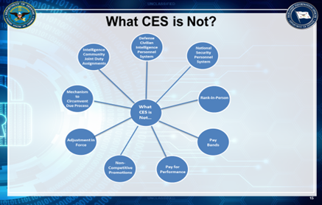

DO - Show Slide 23

SAY: CES IS NOT:

- Defense Civilian Intelligence Personnel System (DCIPS)

- National Security Personnel System (NSPS)

- Rank-in-Person

- Pay Bands

- Pay for Performance

- Employee base pay is not aligned to performance

- Non-Competitive Promotions

- Adjustment–In-Force

- A mechanism to quickly terminate employees

- Intelligence Community Joint Duty Assignments

(Pause)

ASK: Are there any questions?

Transition: Let’s explore the support that is readily available to assist the affected Components with CES implementation.
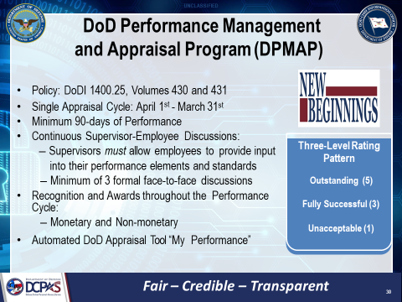

DO - Show Slide 24

SAY: DoD Performance Management and Appraisal Program (DPMAP) - is the performance management and rating system for DoD employees. This program standardizes the approach across DoD and emphasizes the importance of communication and engagement between the supervisor and employee.

Here are key elements to reemphasis to the workforce participants:

- Policy: DoD 1400.25, Volumes 430 and 431
- Single Appraisal Cycle
- Minimum 90 - days of Performance
- Continuous Supervisor - Employee Discussions
- Recognition of Awards
- Automated DoD Appraisal Tool

Transition: It’s time to discuss Labor & Employee Relations.

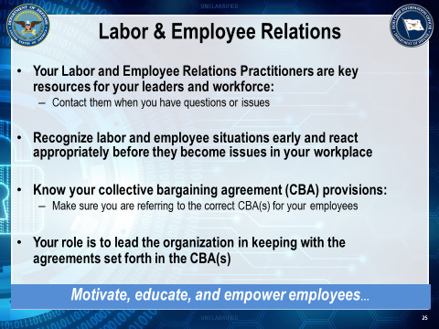

DO - Show Slide 25

SAY: Employee & Labor Relations. The Employee and Labor Relations function of the Human Resources Department is commonly associated with matters such as investigations, counseling and disciplinary actions, but that certainly is not its primary mission.

Here are some Labor & Employee Relations objectives to keep in mind:

- Labor and Employee Relations practitioners are key resources for your workforce and leaders
- Get in front of labor and employee situations early and react appropriately before they become issues
- Be knowledgeable of the collective bargaining agreement (CBA) provisions:
- Know your role in leading the organization in keeping with the agreements set forth in the CBA

Transition: Let’s move to the Cyber Excepted Service – Implementation section

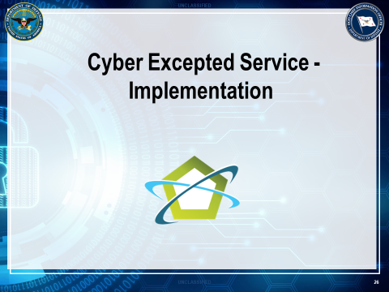

DO - Show Slide 26

SAY: Let’s now turn our attention to CES Implementation Schedule.

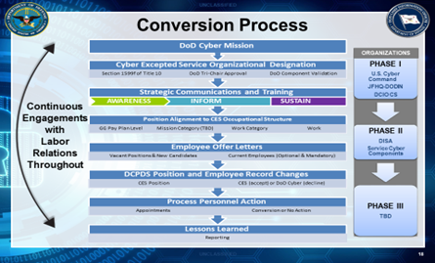

DO - Show Slide 27
SAY: In looking at the CES implementation timeline, you will notice that there are number of activities occurring simultaneously and a host of dependencies. So let’s walk thru this together:

- Policies and Strategic Communications:

- With signed policies, the Office of the DoD CIO and DCPAS began releasing strategic communication messages and products during the month of August-September to the DoD HR and CIO Communities, affected organizations (CES Component Leads), and Servicing HROs for dissemination to their workforce.

- Also, the CES Road Show Engagements have begun across the affected DoD Components and the HR and CIO Communities.

- Training:

- You are currently experiencing one of two Train the Trainers Sessions for Phase 2 CES implementation. After this course, we are hopeful that the remaining Component-led training courses-HR Elements, Leaders Orientation, and Workforce Orientation-will be scheduled.

- HR Planning:

- The CES HRO Toolkit has been developed and released. The CES Team will work closely with the Servicing HROs to plan and sequence the necessary HR activities leading up to conversion.

Transition: Let’s take a look at the CES Implementation Support.

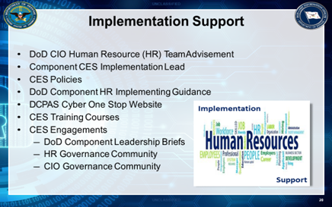

DO - Show Slide 28

SAY: There are a number of tools and resources to assist the affected DoD Components with CES implementation. These resources include:

      - DoD CIO HR Team Advisement

      - Your Component CES Implementation Lead

      - CES Policies

      - CES HR Implementing Guidance and Tool Kit-as previously mentioned the CES Team is anticipating the release of these products in the month of September

      - The DCPAS Cyber One Stop-The single place for everything CES!

      - CES Training Courses-We will discuss these momentarily; these courses will tell you exactly what you need to know about CES and how it will impact your organization, leaders, and the workforce

      - CES Engagements-Similar to the training courses, these engagements will equip you with a solid understanding of what CES is and the status of implementation

Transition: Let’s at CES Training.

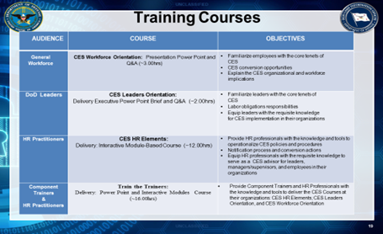

DO - Show Slide 29

SAY: Along with this course, there are a suite of training courses that Components can host at their organizations for their Workforce, Senior Leaders, and HR Practitioners:

      - The CES DoD Workforce Orientation Course is a 3-hour presentation (including a question and answer segment) that has been designed to familiarize the workforce with the core tenets of the new DoD CES personnel system. This course provides an overview of the history, policies, key attributes, benefits, and implementation process for the new personnel system. DoD Component Instructors will conduct this course to equip the workforce with a solid understanding of the key elements of the new personnel system. Upon the completion of this course, the participants will have knowledge of the CES organizational and workforce implications.

      - The CES DoD Leaders Orientation Course is a 2-hour executive presentation (including a question and answer segment) that has been designed to familiarize DoD Leaders with core tenets of the new DoD CES personnel system. This course provides an overview of the history, policies, key attributes, and implementation process for the new personnel system. DoD Component Instructors will conduct this course to equip DoD Component Leaders, Supervisors, and Managers with the requisite knowledge to champion and lead CES implementation at their organizations. Upon the completion of this course, the participants will have the knowledge needed to assist employees with understanding the new personnel system.

      - The CES HR Elements Course is a one and a half day (12-hours) interactive module-based course that has been designed to provide HR Practitioners with the knowledge and tools to operationalize the new CES policies and procedures. Along with providing an overview of key attributes and implementation process for the new personnel system, this course will examine the following topics: CES occupational structure, compensation administration, employment and placement, performance management, performance-based and conduct actions, and grievance and appeal procedures. DoD Component Instructors will conduct this course to equip HR Practitioners (HR Officers, Specialists, Personnel Action Processors, and Liaisons) with the requisite knowledge to serve as a CES advisor for leaders, managers/supervisors, and employees in their organizations.

      - DoD CES Personnel System. This course provides an overview of the history, policies, key attributes, benefits, and implementation process for the new personnel system. DoD Component Instructors will conduct this course to equip the workforce with a solid understanding of the key elements of the new personnel system. Upon the completion of this course, the participants will have knowledge of the CES organizational and workforce implications.

Transition: Also, CES has eLearning Courses targeted towards Workforce, Supervisor/Managers, and
HR Professionals.

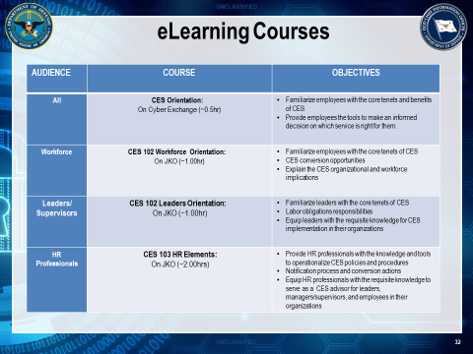

DO - Show Slide 30

SAY: Here are some of the key eLearning course for Workforce employees with a targeted audience: CES Orientation (all), CES 102 Workforce Orientation (workforce), CES 102 Leaders Orientation (Leaders/Supervisors, and CES 103 HR Elements (HR Professionals

Discuss the objectives of each eLearning Courses briefly.

Transition: Now, Let’s wrap up Lesson – Workforce Orientation with a review.

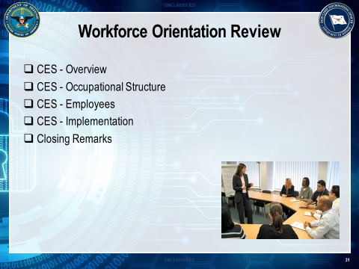

DO - Show Slide 31

SAY: Now that we are at the end of this Lesson – Workforce Orientation, let’s discuss key takeaways from each CES section:

- CES Overview (Background)
- CES Occupational Structure
- CES Employees
- CES Implementation

(Pause)

ASK: Are there any questions related to this lesson?

SAY: Thanks for your attendance and participation with the Workforce Orientation course. The intended outcome is to prepare Workforce Professionals to transition to the Cyber Excepted Service new personnel system.

Instructor Notes

This page intentionally left blank

